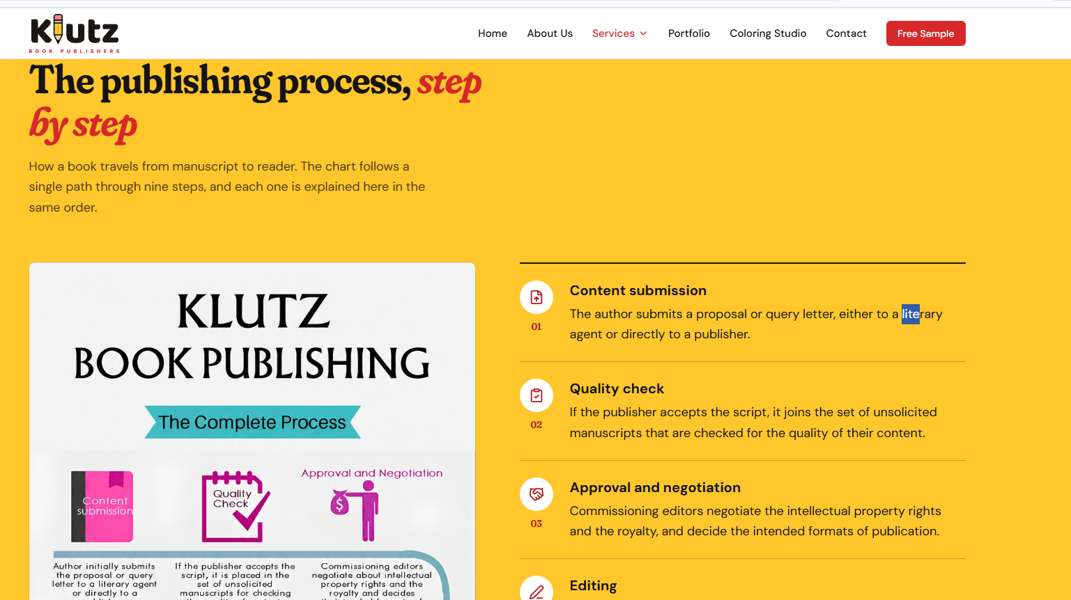
literary agent htao self publishing company hai , aur traditional k steps likhe hue


Pending Confirmation htao

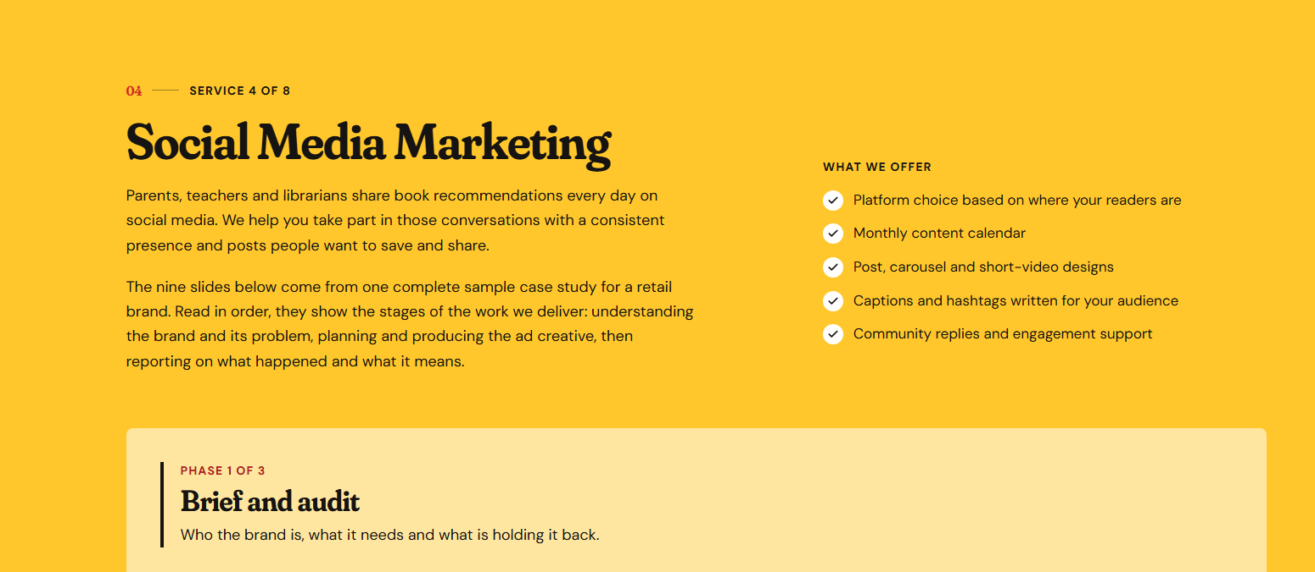

Book publishing brand hai aur marketing mai example clothing brand ki dali hui

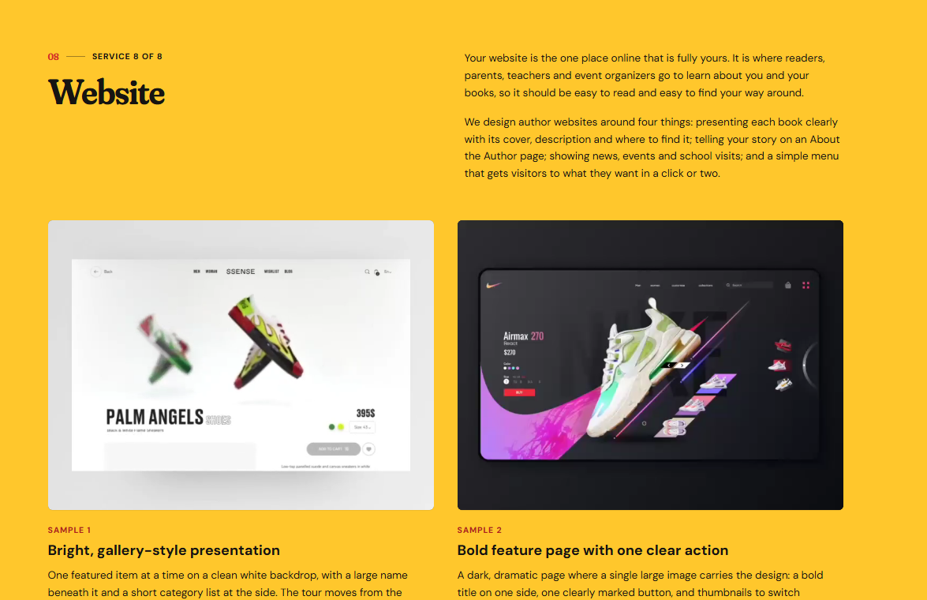

Book ka brand hai

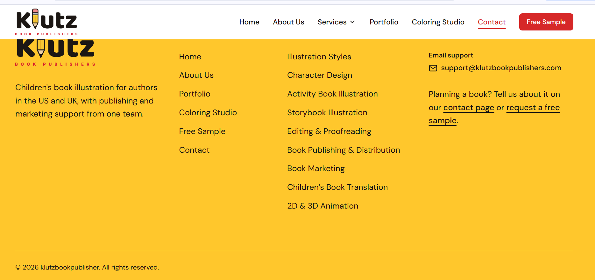

Klutzbookpublishers name hia neeche glt dala hua

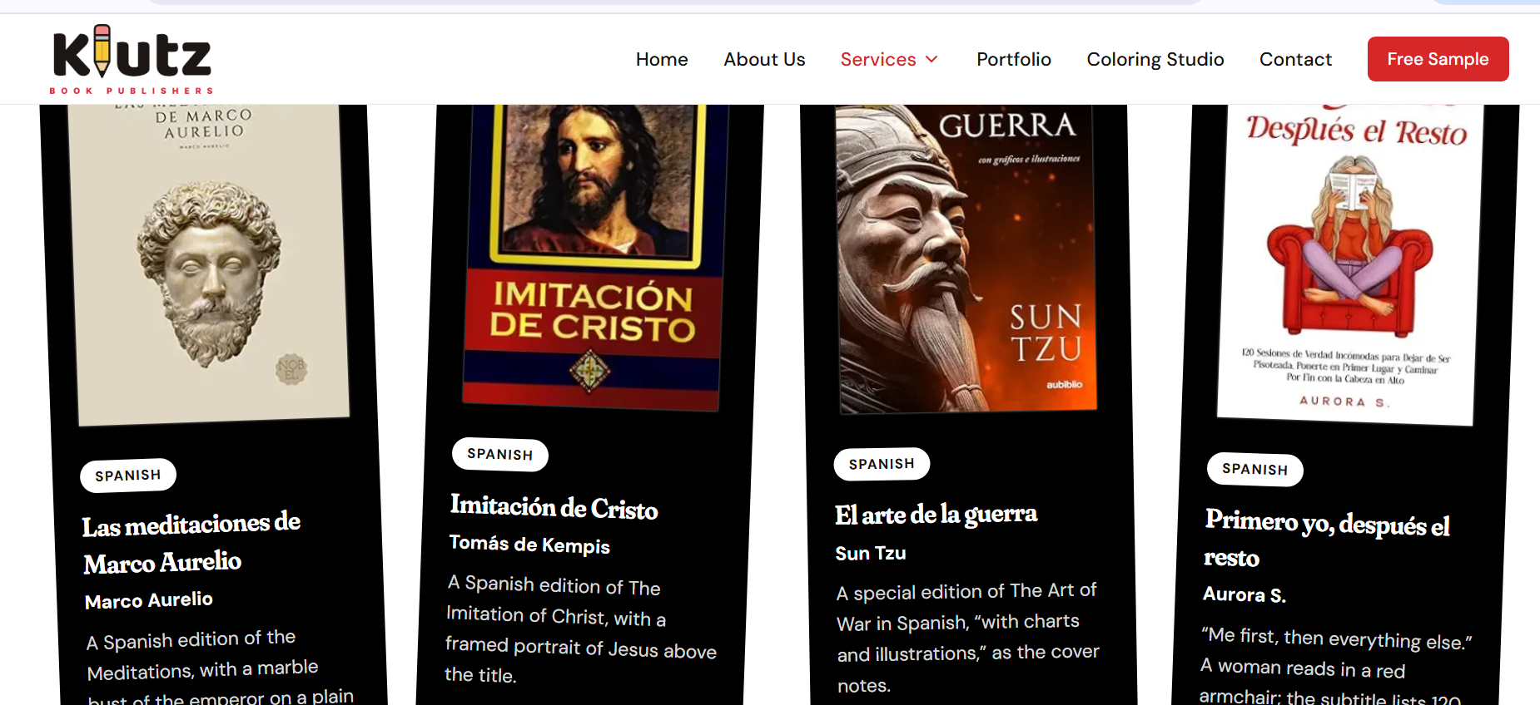

Translation waly section mai books adult literature dali hui lkn children’s brand hai tou children books honi chahiye

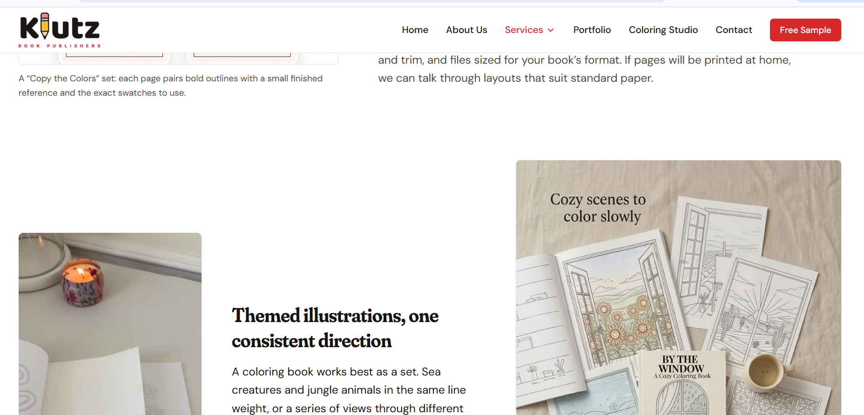

Yeh extra space htao

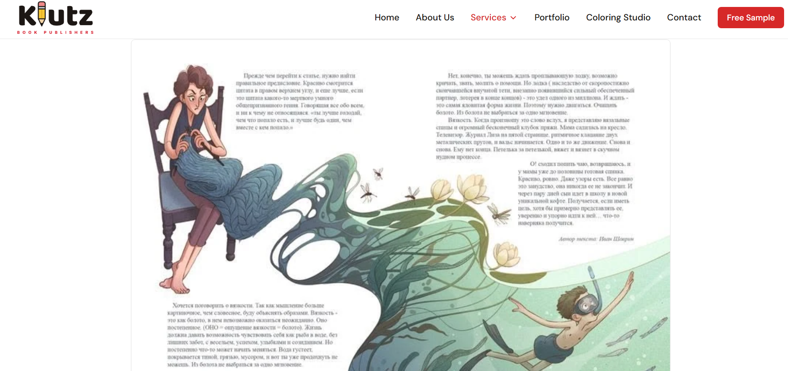

Yeh blur aarhi picture

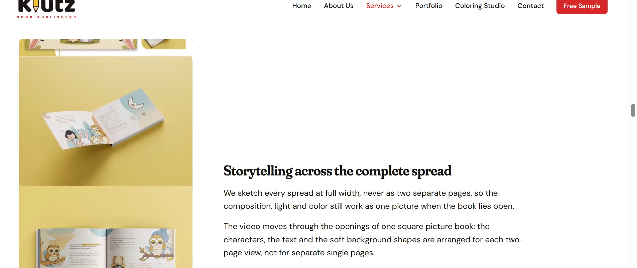

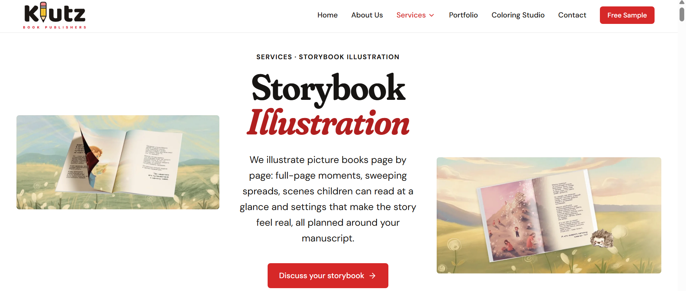

Yeh space bhot aarhi khali khali lg rha

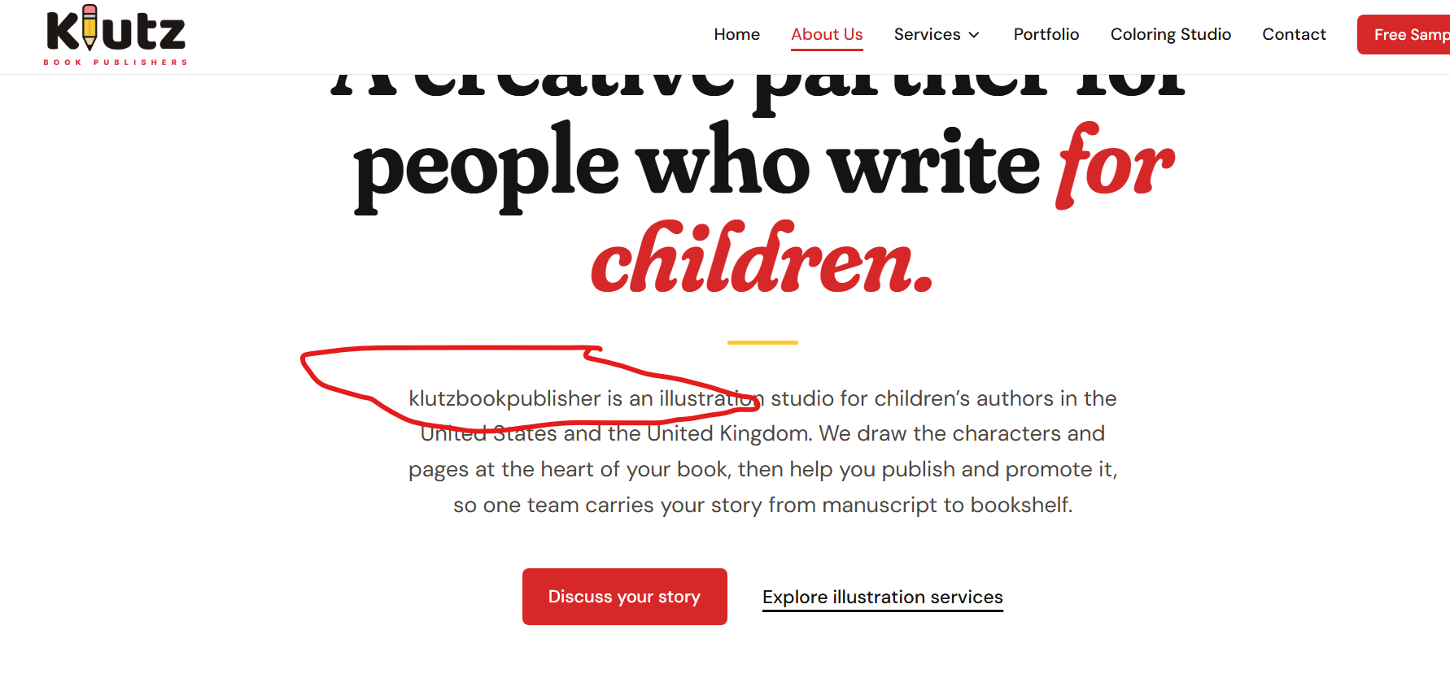

Brand name

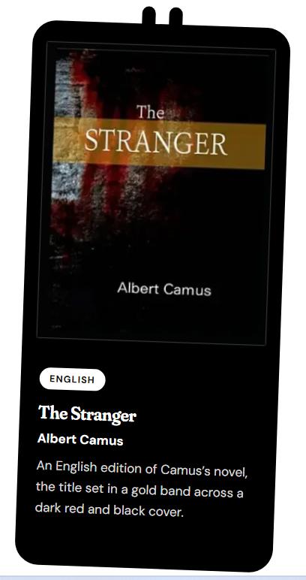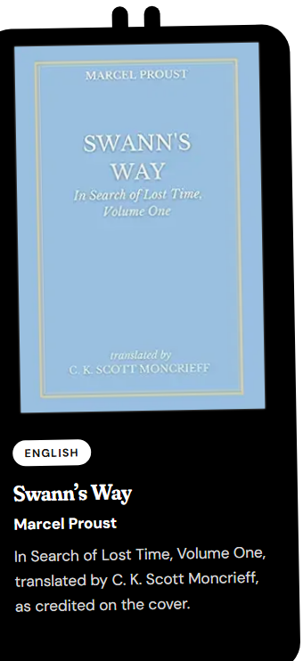

Yeh adultbooks hai sari, list bhi dedi neeche maine
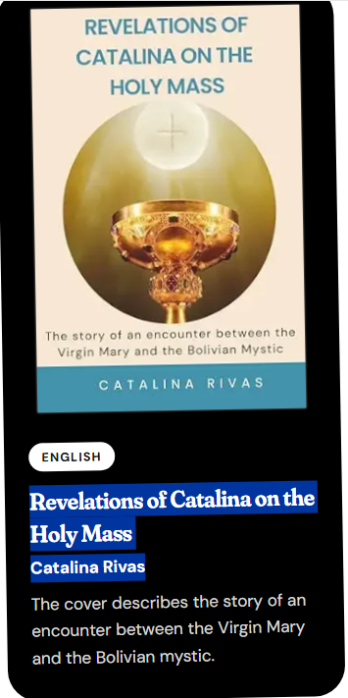

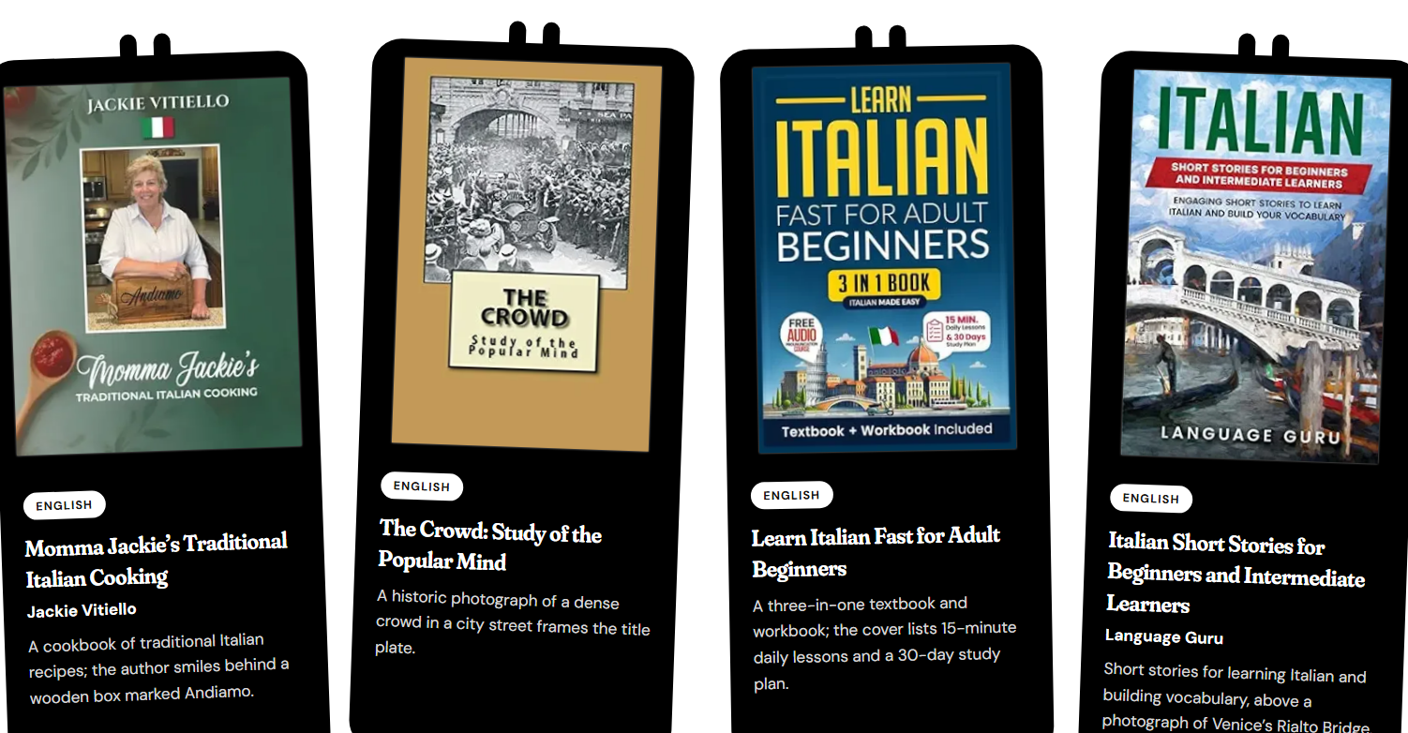
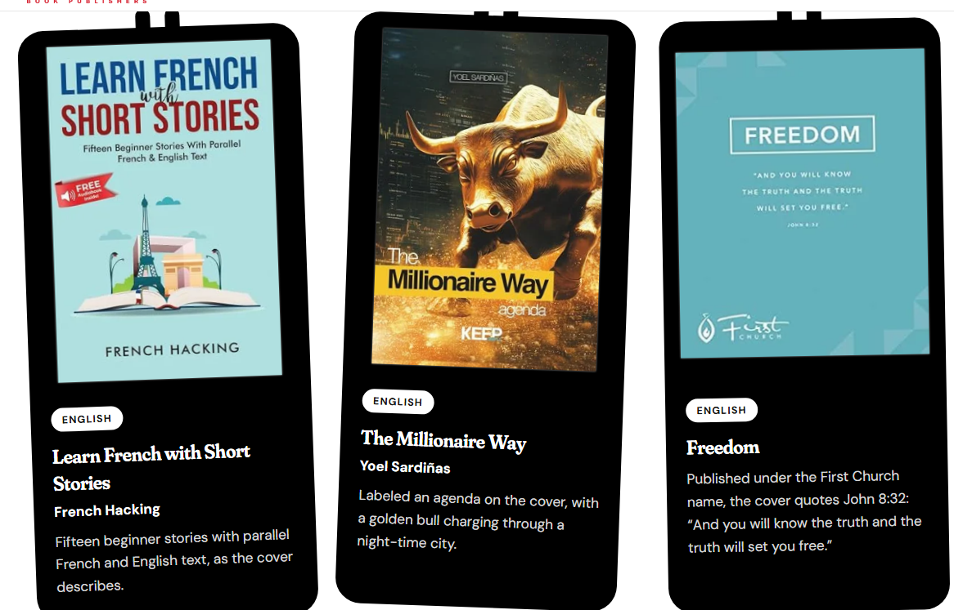
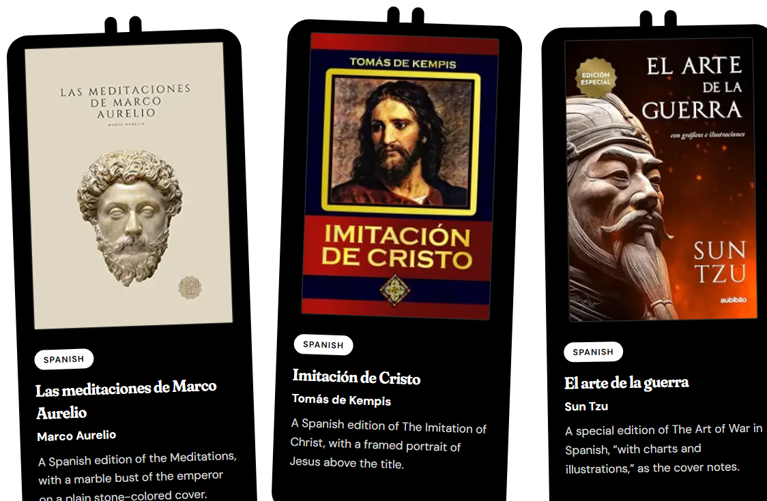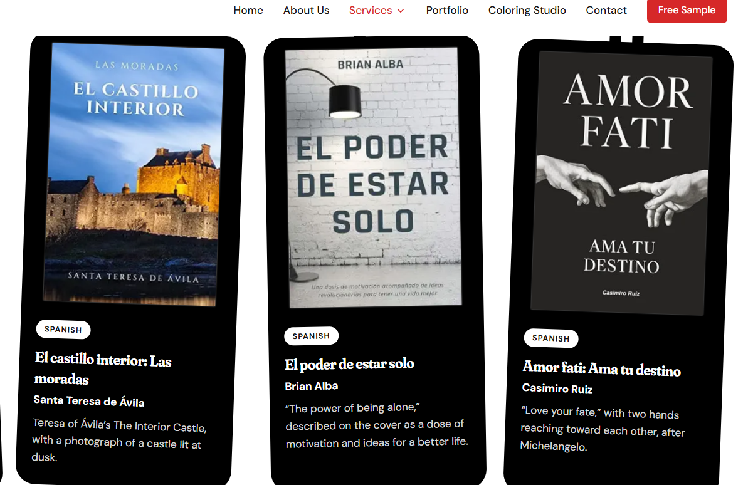

Yeh sari books adult hain

Between Heaven and Earth
40 días de viaje en silencio junto a Dios
Caminando a través del duelo
El Príncipe de Maquiavelo
Necesitaba perderte para encontrarme
The Stranger — Albert Camus
Swann’s Way — Marcel Proust
The Crowd: Study of the Popular Mind
Las meditaciones de Marco Aurelio
El arte de la guerra — Sun Tzu
Cómo dejar de pensar demasiado
Ejercicios de memoria para personas mayores
Noches blancas — Dostoevsky
Une si longue lettre — Mariama Bâ
La Fortune des Rougon — Émile Zola
Vingt-quatre heures de la vie d’une femme
Il fu Mattia Pascal
Der Zauberberg — Thomas Mann
Das Mädchen mit der goldenen Schere
Sylter Briefe
101 Conversations in Simple Italian
Italian Short Stories for Beginners: Book 1
Italian Short Stories for Beginners and Intermediate Learners
Learn French with Short Stories
I fantasmi di Sambuca
Incontri in Sicilia
Gioielli, caffè e Firenze
Il mistero della casa in Sicilia
Oma’s Kreuzworträtsel

Yeh childrens book hai sirf yehi rakho

Paciencia
Eres una chica maravillosa
Eres un chico fantástico
El niño que dejó de ser un desastre
Cahier d’écriture cursive
Les Misérables: High School Edition
Juliette and the Magic Candy Store!
Wens
Samen

